LAB 02

Name: Muhammad Mohsin Nawaz

Class: BSAI-3B

Roll Number: SU92-BSAIM-F25-102

Submitted to: Sir Rasikh Ali

1. Overview and Objectives
An agent is only as good as the problem it has been fitted to. This lab therefore starts from the task environment and works inward: first describing what an agent is supposed to achieve, sense and control (the PEAS framework), then classifying the environment it lives in, and finally building and stress-testing three controllers for a small, concrete problem, a classroom that has to be kept comfortable without wasting energy.

1.1 What the lab covers
- PEAS specifications. Performance measure, Environment, Actuators and Sensors for a physical agent (a campus delivery robot) and a software agent (an LLM student-support assistant).
- Environment classification. Whether each agent can see everything it needs (observability) and whether its actions have fixed outcomes (determinism), with reasons.
- Reflex versus stateful design. A reflex controller and a memory-based controller for the same classroom, compared on identical inputs.
- Failure analysis. How noisy sensor readings near a threshold defeat a stateful controller, and how a hysteresis deadband repairs it.

2. Task 1: PEAS Specifications
A PEAS description fixes the boundaries of a task before any code is written. The performance measure says what counts as success, the environment says where the agent operates, and the actuators and sensors say what it can change and what it can perceive. Rationality is judged against this description, so a vague PEAS leads to a vague agent.

2.1 Agent A: autonomous campus delivery robot
The robot carries parcels along footpaths and through building corridors to drop-off points on campus.
Table 1. PEAS for the delivery robot
Element | Specification
Performance measure | Share of parcels delivered to the right place and on time.  Collisions and near-misses with people, cyclists and vehicles (target: none).  Battery energy used per delivery.
Environment | Footpaths, ramps, lifts, doors and indoor corridors.  Pedestrians and cyclists who move unpredictably.  Weather: rain, fog, glare and wet surfaces.
Actuators | Drive motors with steering and speed control.  Parcel-bay lock and release.  Horn, lights and a small display for handover.
Sensors | Lidar, cameras and ultrasonic range sensors for obstacles.  Wheel encoders and an inertial unit for odometry.  GPS for position, plus a load sensor on the parcel bay.

Trade-off. Speed and safety pull against each other. A robot rewarded only for fast delivery will cut close to people and take risks at crossings. A robot rewarded only for safety may stop and wait whenever a crowd forms and never arrive. A rational design weights the two, with collision avoidance ranked above punctuality.

2.2 Agent B: LLM student-support assistant
The assistant answers questions about courses, registration rules and campus policies through a chat window in the student portal.
Table 2. PEAS for the student-support assistant
Element | Specification
Performance measure | Correctness of answers against official university sources.  Compliance with policy, including refusing what it must not do.  Response time and the share of questions resolved without escalation.
Environment | The portal chat window and its session.  Course catalogue, prerequisite rules and the academic calendar, which change each term.  Students whose real intent is often only partly stated.
Actuators | Text replies and formatted answer cards with links.  Read-only tool calls to university systems.  Hand-off to a human adviser when it cannot answer safely.
Sensors | The student's message and the earlier turns of the conversation.  Results returned by tool calls.  Session metadata such as the signed-in role.

Trade-off. Latency competes with accuracy. Answering straight from the language model is fast but risks inventing a rule that does not exist. Checking every claim against the catalogue is slower but dependable. For official policy the agent should accept the delay, because a wrong deadline costs a student more than a few extra seconds.

3. Task 2: Environment Classification
Classifying the environment tells us what kind of agent is needed. Two properties matter most here. An environment is fully observable if the sensors reveal everything relevant to the decision, and deterministic if an action always produces the same next state. Table 3 classifies both agents and adds three further properties for completeness.
Table 3. Environment properties
Property | Delivery robot | LLM assistant
Observability | Partially observable: sensors cannot see around corners or into pedestrians' intentions. | Partially observable: the true goal behind a question and unwritten policy norms are not in the text.
Determinism | Stochastic: wheel slip, sensor noise and moving people mean the same command can give different results. | Stochastic: a database lookup is repeatable, but the model's wording and sampling are not.
Episodic or sequential | Sequential: a bad turn now affects the rest of the route. | Mostly sequential within a session, since earlier turns shape later answers.
Static or dynamic | Dynamic: the world keeps moving while the robot plans. | Semi-dynamic: records and rules can change between questions.
Discrete or continuous | Continuous positions, speeds and angles. | Discrete text, with a few discrete tool calls.

Table 4. What the agent can see, cannot see, can predict and cannot
Agent | Observable | Hidden | Predictable | Uncertain
Delivery robot | Own speed, distance to the nearest obstacle ahead. | Where a pedestrian will step after a corner. | Braking: a brake command stops the wheels. | How a person reacts on a wet surface.
LLM assistant | The typed question and returned records. | The student's real goal and unwritten norms. | A record lookup returns the stored row. | Exact wording of a generated answer.

Simulator versus the real world. A simulator usually hands the agent exact positions and applies fixed transition rules, which turns the problem into a fully observable, deterministic one. That makes a simulated agent look better than it will in the field. The scripted percepts in Sections 4 and 5 are a small example: the controller here never sees a sensor fault, which is why Section 5 adds noise on purpose.

4. Task 3: Reflex and Stateful Agents

4.1 The classroom controller
The test problem is a smart classroom. The percept is a pair (temperature, occupied) and the controller picks one of four modes. Both agents use the same decision rule, shown in Table 5, so any difference in behaviour comes from memory alone.
Table 5. Decision rule (shared by both agents)
Condition | Mode | Reason
Room not occupied | ECO | Save energy whatever the temperature is; checked first.
Temperature above 26.0 C | COOL | Too warm for people in the room.
Temperature below 20.0 C | WARM | Too cold for people in the room.
Otherwise | IDLE | Comfortable band; no actuation needed.

Six percepts were chosen to cover a repeat, both exact limits, a cold reading and an empty room. Both agents receive exactly this sequence.

4.2 Reflex agent (lab2_percepts.py)
The reflex agent is a pure function of the current percept, as Figure 1 shows. It has no record of what it did before, so it transmits a command every step even when the mode has not changed.
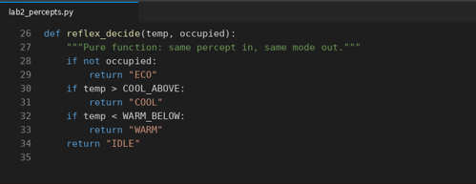
Figure 1.
Table 6. Reflex agent trace (from the run)
Step | Percept (temp, occupied) | Mode chosen | Command
1 | (28.5 C, True) | COOL | Sent
2 | (28.5 C, True) | COOL | Sent again (repeat of step 1)
3 | (26.0 C, True) | IDLE | Sent; 26.0 is not above the limit
4 | (20.0 C, True) | IDLE | Sent again (repeat of step 3)
5 | (18.5 C, True) | WARM | Sent
6 | (28.5 C, False) | ECO | Sent; empty room overrides heat
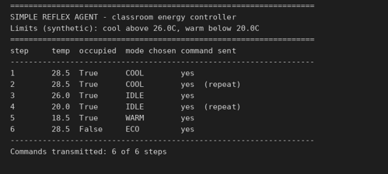
Figure 2.

4.3 Stateful agent (lab2_model.py)
The stateful agent keeps one internal variable, current_mode, which is its model of what the equipment is doing. It reuses the same decision rule but transmits only when the target differs from that remembered mode.
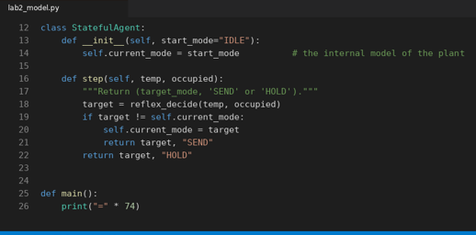
Figure 3.
Table 7. Stateful agent trace (from the run)
Step | Was | Percept | Target | Action | Note
1 | IDLE | (28.5, True) | COOL | SEND | First cooling command.
2 | COOL | (28.5, True) | COOL | HOLD | Duplicate suppressed.
3 | COOL | (26.0, True) | IDLE | SEND | Cooling no longer needed.
4 | IDLE | (20.0, True) | IDLE | HOLD | Already idle.
5 | IDLE | (18.5, True) | WARM | SEND | Heating starts.
6 | WARM | (28.5, False) | ECO | SEND | Empty room takes priority.
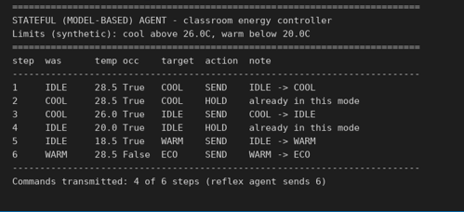
Figure 4.
Comparison. Both agents reached the same target mode at every step. The only difference is communication: 6 transmitted commands for the reflex agent against 4 for the stateful agent, a reduction of one third on this sequence. Steps 2 and 4 were the redundant ones. In a real building each avoided command is a relay or network message that need not be sent.

5. Failure Mode: Sensor Noise Near a Threshold
Memory removes repeated commands, but it does not make the controller stable. The stateful agent still compares each reading with a sharp limit, so a reading that wobbles across the limit changes the target itself, and a changed target is a legitimate reason to send a command. lab2_check.py tests this with eight readings: six that jitter around 26.0 C, followed by a genuine cool-down.

5.1 Observed behaviour
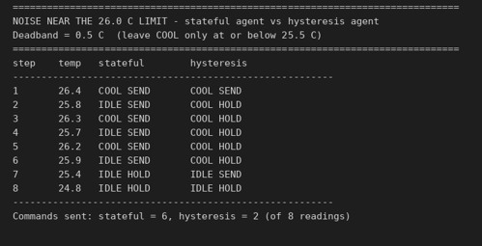
Figure 5. Stateful agent versus hysteresis agent on noisy readings (lab2_check.py).
Steps 1 to 6 show the stateful agent flipping COOL, IDLE, COOL, IDLE, COOL, IDLE and transmitting every time, six commands for six readings. The room temperature barely changed, yet the compressor or valve would be switched on and off six times. Repeated switching wears equipment and wastes energy, and it can be uncomfortable for people in the room.

5.2 Fix: a hysteresis deadband
The fix is to use two different limits depending on direction. The agent enters COOL when the temperature rises above 26.0 C, but only leaves COOL once it falls to 25.5 C or lower. The 0.5 C gap absorbs noise smaller than the gap. Occupancy still overrides immediately, since an empty room should never keep cooling. Figure 6 shows the implementation.
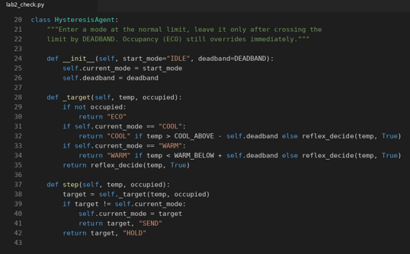
Figure 6.
With the deadband the agent sent one command at step 1, held COOL through the jitter (steps 2 to 6), and sent a second command at step 7 when the reading reached 25.4 C, which was a real cool-down. That is 2 commands for 8 readings, against 6 for the stateful agent.
Table 8. Commands sent on the 8-reading noisy sequence
Agent | Commands | Behaviour
Reflex (no memory) | 8 (by design) | Transmits on every reading.
Stateful | 6 | Chatters across the 26.0 C limit.
Hysteresis (0.5 C) | 2 | Holds COOL through noise, leaves on the real drop.

5.3 Verification suite
Seven automated checks confirm the claims instead of relying on reading the traces. They cover the strict limits, the empty-room rule, duplicate suppression, chatter in the stateful agent, the command ceiling for the hysteresis agent, correct warm-side behaviour, and the occupancy override. All seven passed.
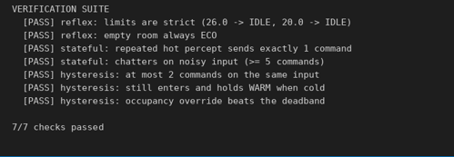
Figure 7.

5.4 Limits of the fix
- Deadband must exceed the noise. The jitter here is about plus or minus 0.4 C, below the 0.5 C margin. Noise larger than the margin would still cause chatter; averaging recent readings or enforcing a minimum time in each mode would then be needed.
- Small comfort cost. While the room is between 25.5 C and 26.0 C the agent keeps cooling even though the plain rule would say IDLE. That is a deliberate, small energy cost in exchange for stability.
- Untested on real data. The readings are scripted. Real sensors drift and fail in ways a simple jitter sequence does not capture.

6. Reflection and Responsible AI Practice

What I learned
A PEAS description is the contract an agent is built against. Writing it forced explicit choices, such as what to measure and what the agent is not allowed to touch. The controller experiments showed a second lesson: giving an agent memory fixes one problem (repeated commands) but leaves another (unstable switching) untouched.

Where it applies
Heating and cooling systems, factory equipment and mobile robots all combine state tracking with hysteresis in practice, because the cost of rapid switching is physical wear and wasted energy rather than a wrong answer on a screen.

What surprised me
The stateful agent looked like a strict improvement on the first trace and only failed once noise was introduced. A design can look correct on clean inputs and still be fragile, which is why the noisy test mattered more than the extra trace rows.

Responsible AI notes
- Measure side effects. A performance measure that counts only comfort or only delivery speed ignores equipment wear, energy use and safety around people.
- Limit what the assistant can do. The student-support agent is safer because it is read-only and must cite a source or escalate. Narrow permissions are part of the design, not an afterthought.
- State the assumptions. The limits, the deadband and the percept sequences here are invented, and any real deployment would need values justified for that building and tested on real sensor data.

